**Topic:- Spring REST using Spring Boot 3**

**Hands on 1**

**Q.1.) Create a Spring Web Project using Maven** 

**Solution**

**Code**

**SpringLearnApplication.java**

package com.cognizant.spring_learn;

import org.springframework.boot.SpringApplication;

import org.springframework.boot.autoconfigure.SpringBootApplication;

@SpringBootApplication

public class SpringLearnApplication {

public static void main(String[] args) {

System.*out*.println("SpringLearnApplication Started...");

SpringApplication.*run*(SpringLearnApplication.class, args);

}

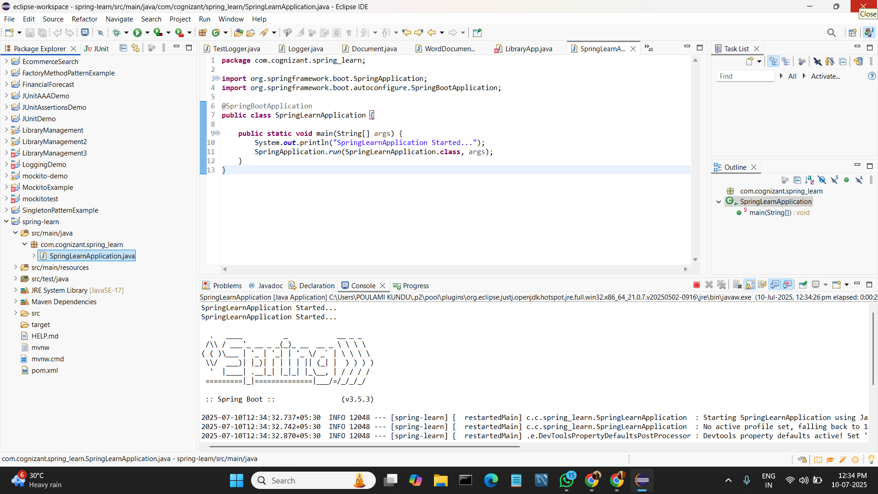}

**Hands on 4**

**Spring Core – Load Country from Spring Configuration XML   
  
An airlines website is going to support booking on four countries. There will be a drop down on the home page of this website to select the respective country. It is also important to store the two-character ISO code of each country.**

|  |  |
| --- | --- |
| **Code** | **Name** |
| **US** | **United States** |
| **DE** | **Germany** |
| **IN** | **India** |
| **JP** | **Japan** |

**Above data has to be stored in spring configuration file. Write a program to read this configuration file and display the details.**

**SOLUTION:**

**CODE:**

**pom.xml**

<project xmlns="http://maven.apache.org/POM/4.0.0"

xmlns:xsi="http://www.w3.org/2001/XMLSchema-instance"

xsi:schemaLocation="http://maven.apache.org/POM/4.0.0 https://maven.apache.org/xsd/maven-4.0.0.xsd">

<modelVersion>4.0.0</modelVersion>

<groupId>com.cognizant.springlearn</groupId>

<artifactId>spring-country-demo</artifactId>

<version>0.0.1-SNAPSHOT</version>

<dependencies>

<dependency>

<groupId>org.springframework</groupId>

<artifactId>spring-context</artifactId>

<version>5.3.38</version>

</dependency>

<dependency>

<groupId>org.slf4j</groupId>

<artifactId>slf4j-simple</artifactId>

<version>2.0.12</version>

</dependency>

</dependencies>

</project>

**Country.java**

package com.cognizant.springlearn;

import org.slf4j.Logger;

import org.slf4j.LoggerFactory;

public class Country {

private static final Logger *LOGGER* = LoggerFactory.*getLogger*(Country.class);

private String code;

private String name;

public Country() {

*LOGGER*.debug("Inside Country Constructor.");

}

public String getCode() {

*LOGGER*.debug("Inside getCode method.");

return code;

}

public void setCode(String code) {

*LOGGER*.debug("Inside setCode method.");

this.code = code;

}

public String getName() {

*LOGGER*.debug("Inside getName method.");

return name;

}

public void setName(String name) {

*LOGGER*.debug("Inside setName method.");

this.name = name;

}

*@Override*

public String toString() {

return "Country [code=" + code + ", name=" + name + "]";

}

}

**country.xml**

<?xml version="1.0" encoding="UTF-8"?>

<beans xmlns="http://www.springframework.org/schema/beans"

xmlns:xsi="http://www.w3.org/2001/XMLSchema-instance"

xsi:schemaLocation="

http://www.springframework.org/schema/beans

https://www.springframework.org/schema/beans/spring-beans.xsd">

<bean id="country" class="com.cognizant.springlearn.Country">

<property name="code" value="IN" />

<property name="name" value="India" />

</bean>

</beans>

**SpringLearnApplication.java**

package com.cognizant.springlearn;

import org.slf4j.Logger;

import org.slf4j.LoggerFactory;

import org.springframework.context.ApplicationContext;

import org.springframework.context.support.ClassPathXmlApplicationContext;

public class SpringLearnApplication {

private static final Logger ***LOGGER*** = LoggerFactory.*getLogger*(SpringLearnApplication.class);

public static void main(String[] args) {

*displayCountry*();

}

public static void displayCountry() {

ApplicationContext context = new ClassPathXmlApplicationContext("country.xml");

Country country = (Country) context.getBean("country", Country.class);

***LOGGER***.debug("Country : {}", country.toString());

}

}

**Simplelogger.properties**

org.slf4j.simpleLogger.defaultLogLevel=debug



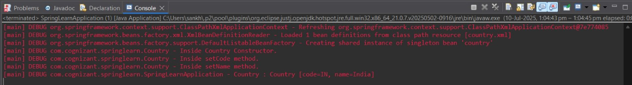**OUTPUT:**

